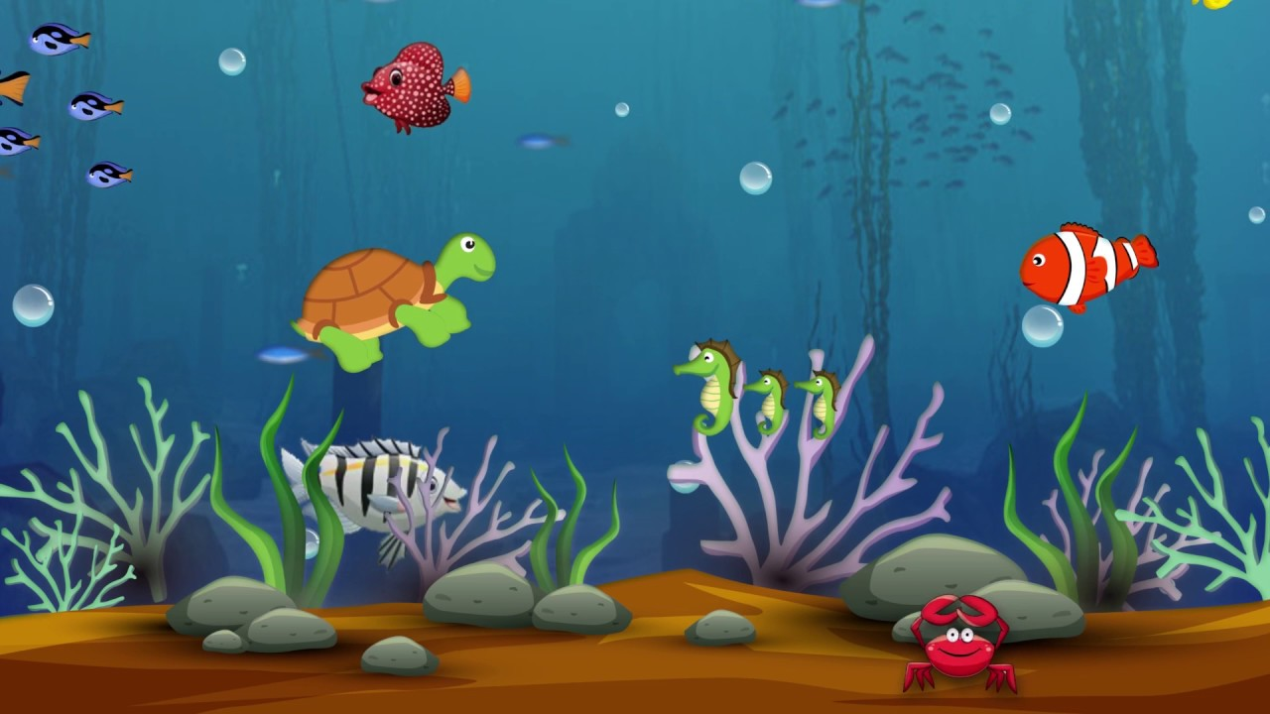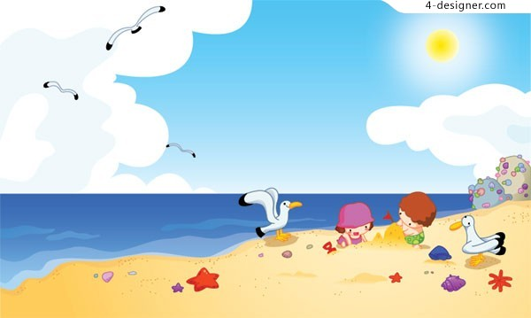

P3 Class News

May/June 2023

# Numeracy

This half term we will be focusing on halving and doubling numbers as well as fractions of shapes and numbers. We will also be revising all of the topics covered this year, especially our number bonds to 10 and 20 as this is crucial for P4.

Please ensure your child is forming numbers the correct way. You can work with them at home regarding their number bonds in both addition and subtraction.

# Literacy

Our main focus is recount writing where we will look at retelling events that have happened. We will also be writing a recount of our trip. Linking with our topic, we will be writing postcards, ice cream orders and lots of things related to the seaside. As always, we will remember capital letters and full stops.

**Phonics**

We will continue to focus on a sound a week and have our daily phonics sessions. Please continue to support your child at home.

# Topic Work

Our last half term topic will be The Seaside. We will be looking at the beach, the sea and talking lots about holidays. Some focus will be on animals found under the water and we will be looking at different holidays all around the world. As well as different holiday destinations, we will be looking at different features of the beach and will compare holidays then and now.



**How can you help?**

**Here are some home learning ideas.**

As always, reading is the most important thing you can do with your child. They only need 10 minutes a day and this will maximize learning potential. If you do not already, please remember to sign their reading record books.

Practice quick recall of number facts at home, particularly different ways to make 10 and 20 Ask them different ways to make 10 and 20 in different contexts.

Talk to your child about some holidays they have had and discuss what they did; what they packed and what they saw. Talk to them about holidays you went on when you were younger.

**Other Information**

Please check your child’s schoolbag each night for homework/ notes.

**Please send in a strong plastic bag ASAP as your child will be getting all their school books home soon AND WE HAVE LOTS!**

Please ensure your child has a pair of P.E shoes in school. Our P.E days are Monday and Wednesday. Thank you for being organised and all your support this year.

**Important Dates**

26th May – Sports Day

Friday 16th June – Trip to Newcastle Cocos and the beach

30th June – Last half day of term for Summer and class party please bring in Party Food

**Healthy Eating** – The children have been really great at bringing in healthy snacks for their break so thank you. The healthy break chart will continue to the end of the year.

**MCj00886480000[1]**