 P1 Parent Newsletter – Spring Term 2

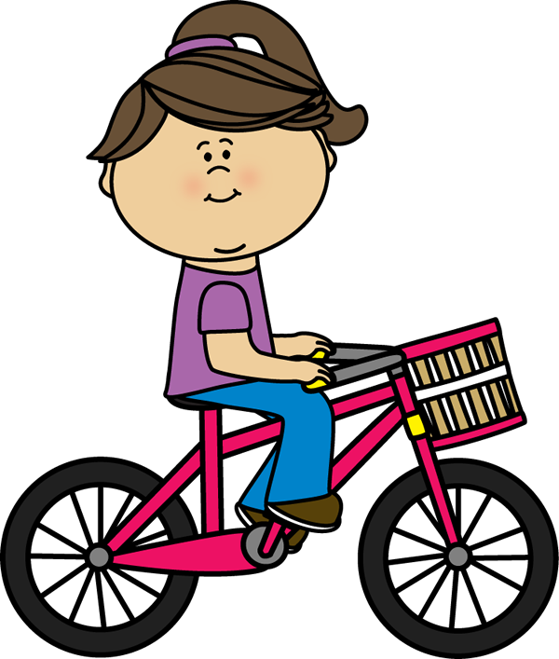

This half term we will be learning all about Transport



We are enjoying spending more time outdoors in the Foundation Stage this year. Please make sure your child has a waterproof suit / coat and trousers in school and a pair of welly boots.

Thank you if your child has already been kitted out!

Please feel very welcome to speak to me if you have any concerns. You can do this by either phoning the school secretary or sending me a message on Seesaw.

Mrs Jebb 😊

* Our PE day is Thursday. Please come to school dressed in PE kit.
* Please keep sending in £3 snack money every Monday in their snack wallets.

In Numeracy we will be:

* Naming + recognizing numbers 1-10
* Writing numbers 1-10
* Finding sets within 10
* Adding numbers within 5
* Describing and naming 2D shapes
* Measuring objects by weight and length

In Literacy we will be:

* Copying sentences written by the teacher
* Sequencing simple stories
* Learning how to form upper and lower case letters correctly
* Reading lots of books based around our topic of Transport
* Learning tricky words

In Phonics we will be:

* Revising sounds – satpinckehrmdgoulf
* Learning new sounds – b j z w v
* Using all the sounds we have learnt to help us write more independently.
* Blending sounds together to make simple words